Git Assignment 1

Install GIT & make sure it is added into PATH.

Use GIT as local VCS. Steps to follow:

1. Create a directory ‘project_dir’ & cd to ‘project_dir’. C:\Users\HFT0002\Desktop\asgnmnt\1.PNG
2. Initialize git version database. (git init) C:\Users\HFT0002\Desktop\asgnmnt\2.PNG
3. Create a new file index.html. 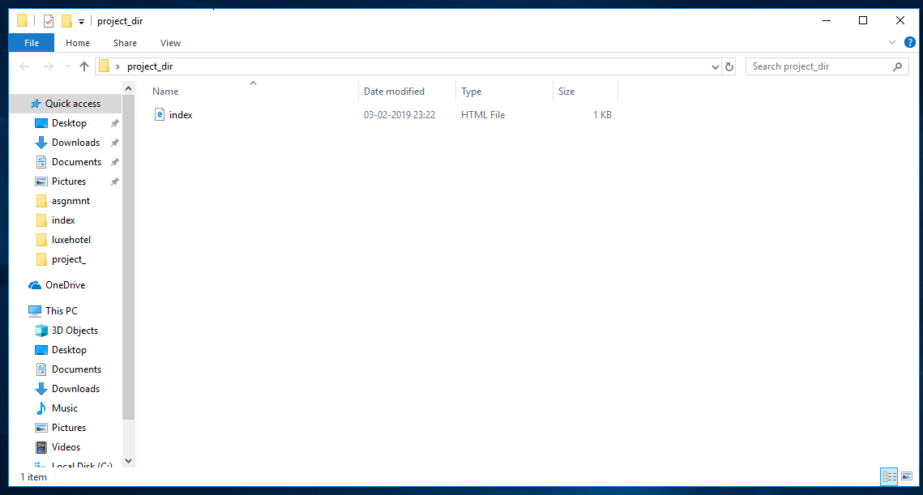
4. Check the git status. You should find index.html as untracked file. 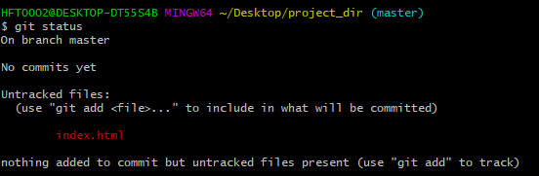
5. Stage the index.html file. 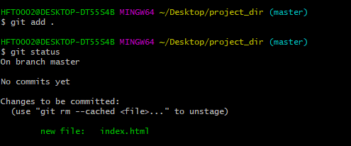
6. Commit index.html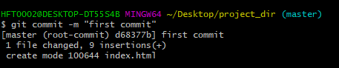
7. Make few changes in index.html & create a new file info.txt file. 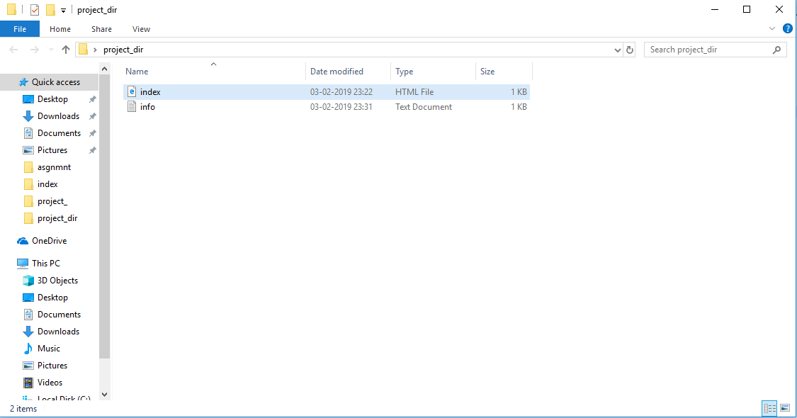
8. Check git status. You should find index.html & info.txt as untracked files. 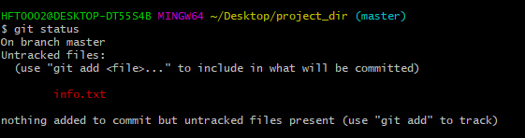
9. Configure GIT to ignore all txt files. 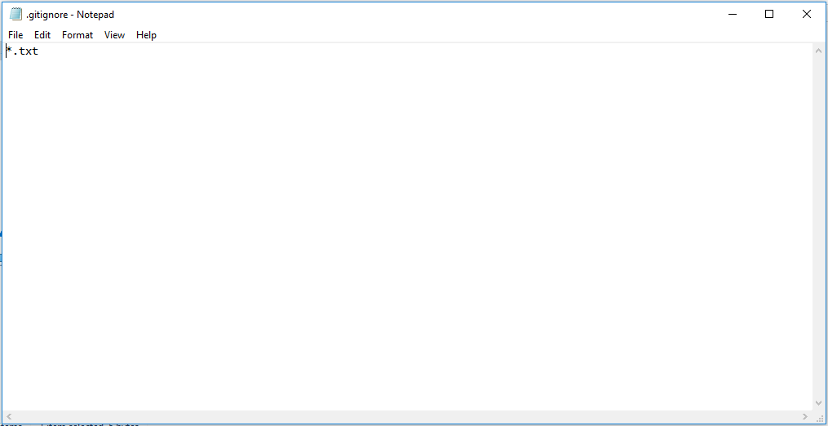
10. Again check the git status. You should find only index.html as untracked file. 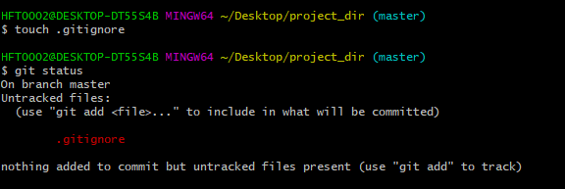
11. State & commit index.html
12. Log all your comments so far. 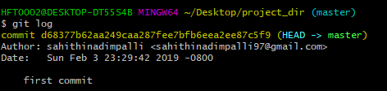
13. Make some changes in index.html. 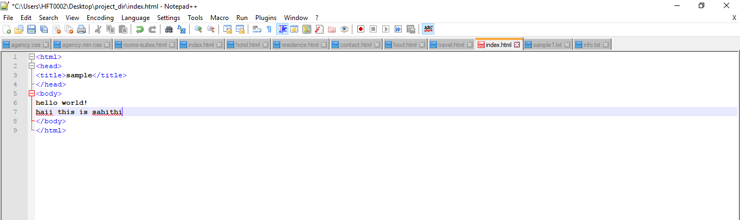
14. Revert the change made in the previous step using git command. C:\Users\HFT0002\Desktop\asgnmnt\14.1.PNG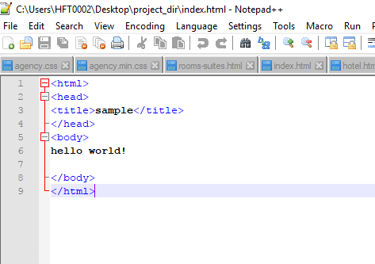
15. Again change index.html. 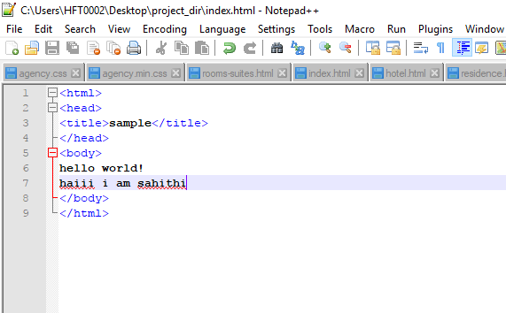
16. Stage index.html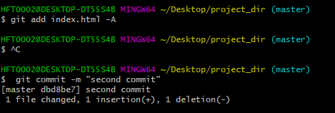
17. Revert back the last stage. C:\Users\HFT0002\Desktop\asgnmnt\17.1.PNG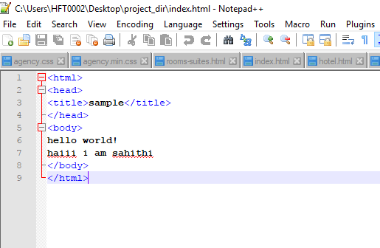
18. Rename ‘add’ command to ‘my-add’. C:\Users\HFT0002\Desktop\asgnmnt\18.1.PNG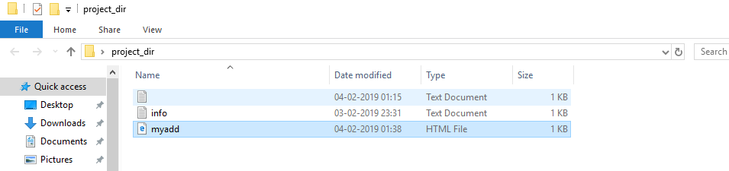
19. Using my_add command Stage index.html again & commit the changes. 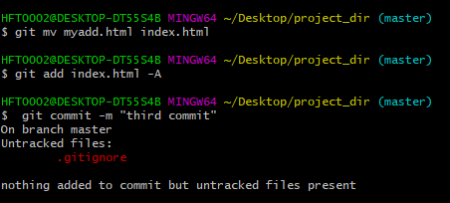
20. Revert the last commit. C:\Users\HFT0002\Desktop\asgnmnt\20.PNG